**INSIGHTS AND QUESTIONS:**

* **Which users have contributed the most in terms of comments, edits, and votes?**

**QUERY:**

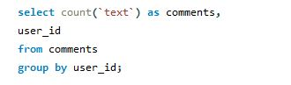

**RESULTS:**

**Insights:**   
The data is **incomplete** for answering this question accurately because:

* The votes table does not have a direct relationship with the users table.
* The edits column does not exist in any table, so we cannot determine user contributions based on edits.
* However, based on the comments table, users **1001 and 1002** have contributed the most, with **3 comments each**.
* **What types of badges are most commonly earned, and which users are the top earners?**

**Query:**

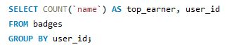**For most common badges:**

**RESULTS:**

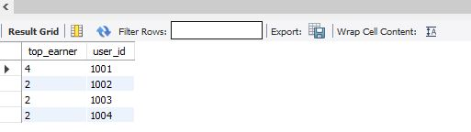

**For top earners:**

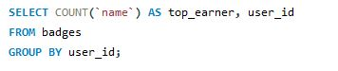

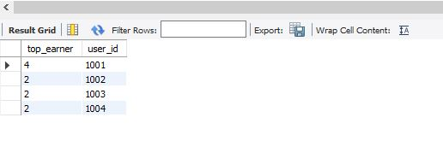**RESULTS:**

**Insights:**

* The most commonly earned badge is **'GOLD CONTRIBUTOR'**, appearing **4 times** in the dataset.
* The top badge earner is **user 1001**, who has earned **4 badges**, making them the highest-ranking user in terms of badge achievements.
* **Which tags are associated with the highest-scoring posts?**

**Insights:**

* There is **no direct relationship** between the posts and tags tables since neither table contains the other's primary key as a foreign key.
* Without a **junction table** (e.g., post_tags), we cannot **accurately** determine which tags are linked to the highest-scoring posts.
* **How often are related questions linked, and what does this say about knowledge sharing?**

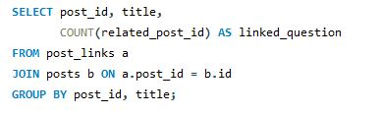**Query:**

**RESULTS:**



**Insights:**

* The results show that **5 different post IDs** have **2 related questions each**.
* This suggests that users frequently **refer to related content**, especially for **fundamental SQL topics** like **joins** and **database queries**.
* The data implies that **knowledge-sharing is active**, and users **engage with foundational topics** to gain a better understanding.